Hong Kong Monetary Authority (HKMA)
Threat Intelligence (TI) Playbook


Version Control
No. | Date | Author | Description
0.1 | 07 Jun 2024 | PwC (Herbert Kwok) | 1st draft
0.2 | 31 Jul 2024 | PwC (Herbert Kwok) | 2nd draft  1) CTO – About Completion Phase  New  •Expected Turnaround of Incident / CVE  •Monthly Statistics & Report  Modified  •Incident Escalation for HKMA Evaluation  Enhancement  •Follow-up Actions for CVE Escalation  - Communication with System Owner(s)  •Follow-up Actions for Incident Escalation  - Analysis Template  - IOCs Blocking  2) Threat Hunting – Initiating Phase  New  •Threat Actor Profiling  •Weekly Review and Update of IOCs in HKMA Internal TI Source  •Evaluating IOC Impact and Initiating Incident Response (IR)  3) SOC – About Completion Phase  New  •Supporting SOC Operations  •Delivering Threat Hunting Analysis to SOC  4) Incident Response (IR) – Initiating Phase  New  •IR Initiation and Notifications Phase  •Investigation Phase  •Drilling & Reporting Phase
0.3 | 25 Sept 2024 | PwC (Herbert Kwok) | 3rd Draft  1) CTO – About Completion Phase  Note  •HKMA:  - Released the latest version of “SOC_TI_Workflow_20240902” (updated on 2024-09-02).  •PwC:  - In Progress: drafting the 3rd draft of the TI SOP, which aligns with the workflow of the cross-functional flowchart.  Enhancement  •Communication with System Owner(s)  - Email Template  Modified  •High / Critical Case  - Route JIRA ticket to affected stakeholders  - Users creates sub-ticket, update sub-task with evidence when patching completed  •Medium / Low Case  - Send out notification emails via Outlook, asking users remediate the vulnerability  •Patching Confirmation  - Confirm remediation with the evidence of screenshot  •CVE Escalation for HKMA Evaluation  - Added “Check with users via Outlook email, asking potentially affected parties explicitly if they are using the affected system and its version”  •Non-office Hour Workflow for Critical Case  New  •Threat Classification  - CVA Criteria Table  - Define Critical / High / Medium / Low severity levels for CVEs  - Initiate corresponding follow-up actions
0.4 | 05 Nov 2024 | PwC (Herbert Kwok) | Latest Endorsement  1) CTO  Modified  •High / Critical Case  - Add a step “Email to System Owner confirm if system is affected” before routing JIRA sub-ticket to System Owner  - TI on-site analyst creates sub-ticket to fill in the response from System Owner’s email reply, instead of System Owner creating sub-ticket and filling in the information themselves  - Set the component of JIRA sub-ticket to “TI follow up” instead of “TI alert escalation”  •Add Case Categorization  - Requested by HKMA to align OGCIO Threat Handling Practice  - Social threats (e.g., social engineering attacks, phishing)  - Technical Threats (e.g., Malware, zero-day exploits)  - Environmental Threats (e.g., hardware failures, outage)  - Others (e.g., threat landscape)  •Day-to-day duties for CVEs sweeping  - As requested by HKMA, if the threat is issued by OGCIO or PwC Proprietary Critical Vulnerability Alert, the TI on-site analyst should create a JIRA ticket for every threat follow-up.  •Monthly Statistics Report  - As requested by HKMA, upcoming following statistics will be included:  - Communications/Settlement Phishing Email  - Threat Hunt  - OGCIO High Threat Security Alert  - PwC Proprietary Critical Vulnerability Alert  2) Threat Hunt  Add  •Objectives of Threat Hunting  - Add an outcome “Ensure whether users had run the unblocked malware in HKMA computer by Threat Hunting in Splunk, and other EDR Solutions”  •Scope of Threat Hunting  - Add Threat Hunting Scope, agreed with HKMA  - HKMA Related  - Regional Focus  - CVE / Vulnerabilities  - Technology Related  - PwC Proprietary Cyber Threat Intelligence Weekly Report  •Coverage of finding Indicators of Compromise (IoCs) for threat hunting in security solutions  - Mapping table is added  •Validate the findings of IoCs  - Add the method of validating the following hits:  - False Positive  - True Positive with low/medium confidence  - True Positive with high confidence  Modified  •Threat Actor Profiling  - The following details should be included, if available (if not, fill in N/A):  - Aliases  - Country of Origin  - Known Targets  - Active Since  - Target Sectors  - Primary Objectives  - Techniques  Remove  •Review and Consolidation HKMA Internal TI Source  - The IOC consolidation is inefficient after trial run, we proposed to remove this part due to no any integration in place, there is no impact on current threat hunting tasks.  3) SOC  Modified  •TI Analysis Coordination with SOC  - Add a case study: “Hash Value of File Analysis in JIRA ticket provided by SOC”  Remove  •Delivering Threat Hunting Analysis to SOC  - Reason - Since TI will conduct threat hunting itself, there is no need to deliver to SOC afterwards  4) Incident Response (IR)  Modified  •IR Initiation and Notifications Phase  - If a ticket/incident is related to TI, AD(IT)(ITS)3 will kick off IR to the PwC TI Team. If the ticket is related to SOC, kick off IR to the PwC SOC Team.
0.5 | 27 Nov 2024 | PwC (Herbert Kwok) | 1) CTO (1st Modification of Latest Endorsement)  Add  •Dark Web Monitoring Alerts Handling  - On working days at 10:00 AM and 4:00 PM, the TI on-site analyst will monitor alerts from Dark Web Monitoring (DWM) in the PwC JIRA Platform  - Created dark web monitoring alert ticket in JIRA ticket with title, component, status  Modified  •High / Critical Case Follow Up  - Requested by AD(IT)(ITS)3, set the component of JIRA sub-ticket to “TI alert escalation” instead of “TI follow up” to track progress of system owner for further follow up
0.5 | 20 Dec 2024 | PwC (Herbert Kwok) | 1) CTO (2nd Modification of Latest Endorsement)  Modified  •Medium / Low Severity CVE Processing  - Requested by AD(IT)(ITS)3, the following actions should be taken based on the Final Severity Level of vulnerability being ‘Low’:  - Perform Further Investigation and Document Findings in JIRA  - (New Addition) No need to send out a notification email to the system owner  3) Security Operation Centre (SOC) (1st Modification of Latest Endorsement)  Add  •TI Requests Findings by SOC  - Requested by AD(IT)(ITS)3, if the TI on-site analyst identifies Indicators of Compromise (IoCs) using HKMA security tools (e.g., Splunk, Sentinel One) during a threat hunt, the case should be passed to the SOC on-site analyst for further action.  - TI on-site analyst will create a Jira sub-ticket under the threat hunt parent ticket for the passing case to SOC.  - SOC on-site analyst will perform analysis on HKMA security solutions, gather and provide observations in the sub-ticket accordingly where necessary.
0.6 | 21 Jan 2025 | PwC (Herbert Kwok) | 1) CTO (3rd Modification of Latest Endorsement)  Add  • HKMA Domain Monitoring (Trial-Run)  - Agreed by AD(IT)(ITS)3 and PwC, it is to expand the existing TI coverage process to regularly search reputable feeds for keywords (e.g., “HKMA” or “hkma.gov.hk”) to cover social media monitoring.  - AD(IT)(ITS)3 agreed to trial-run and if suitable.  - During trial-run, explore (a) automation and (b) additional use cases.  Modify  • Template for documenting CVEs in the Outlook Email  - Requested by AD(IT)(ITS)3, place the indicator “Exploited in the Wild” as the first row under the attribute “Exploitation Metrics” since it has a greater impact to the vulnerability severity level compared to the indicators “Exploitable”, “Remotely Exploitable”, and “Exploitable by Non-Privileged Accounts.”  2) Threat Hunting (1st Modification of Latest Endorsement)  Modify  • Validate the findings of IoCs  - Below is the detailed process for handling the security hits:  - Research IP Purpose, Pass to SOC  - Confirm if APT Targeting  - Update Severity Level to ‘Critical’ if APT Targeting  - Request blocking IoCs within one business day if APT Targeting  3) SOC (2nd Modification of Latest Endorsement)  Modify  • TI Requests Findings from SOC  - TI provide the ticket content to SOC  - Include Threat Hunting findings (i.e., the purpose of the IP leveraged by the threat actor)  - SOC will provide the following observations if the IoCs are IP addresses:  - Identify any malicious inbound and outbound traffic  - Confirm whether such activity has been denied  - Observe whether there is any callback (for C2 IP address only)
0.6 | 24 Feb 2025 | PwC (Herbert Kwok) | 1) CTO (4th Modification of Latest Endorsement)  Modified  • Phishing Email Handling  - Added “Neutral” into original classified types (“Unwanted”, “Spam”, “Phishing”)  - As obtaining feedback from the HKMA Communications & Settlement Team and agreed by AD(IT)(ITS)3, emails reported without any phishing indicators will now be marked as "Neutral”.  • Submit Block IP Request to HKMA System Owner  - As requested by the HKMA Infrastructure Team System Owner A(SYS)(IT)(IS)10, when a TI on-site analyst creates a ticket including an IP Address request for blocking, the brackets between the dots will be removed for smoother operation (i.e., making it more convenient for the system owner to input the malicious IP Address into the NIPS block list.  2) Threat Hunting (2nd Modification of Latest Endorsement)  Modify  • Conduct Threat Hunt against Specific Active Advanced Persistent Threat (APT) Group  - Suggested by AD(IT)(ITS)3 as a lesson learned, to conduct threat hunts focusing on opportunistic threat actors based on their recent activity.
0.7 | 26 Mar 2025 | PwC (Herbert Kwok) | Latest Endorsement on 25 Feb 2025  1) CTO (1st Modification of Latest Endorsement)  Modified  • Phishing Email Handling  - As requested by AD(IT)(ITS)3, the categories "Unwanted" and "Neutral" have been removed. The new categories are "Spam" or "Phishing".  - Justification: To unify the outcome of analyzing the reported email and prevent subjective conclusions.  2) Threat Hunting (1st Modification of Latest Endorsement)  Enhance  • Scope of Threat Hunting  - Expand the scope of threat hunting - Trend-Related Threats (Not limited but include the following):  - Remote Access Tools  - InfoStealers  - Provide a mapping of Remote Access Tools with corresponding threat actor groups for reference
0.8 | 31 July 2025 | PwC (Herbert Kwok) | 1) CTO (2nd Modification of Latest Endorsement)  Modified  • CVE Severity Level  - Follow the Standard released by public sources, including vendors, DPO, and NVD.  • CVE Notification Email Delivery  - Include all IT, FMI, HKDPB Associate Directors (ADs) in CVE notification emails.  • Follow-up actions required by users if affected by CVE  - Include a Summary Table in CVE notification email for System Owner to fill in / provide the following information:  - Internet Facing (Yes / No)  - Affected System / Server IP(s)  - Target Solution Apply / Patch Date  • Follow-up actions required by TI if affected by CVE  - Assign JIRA ticket to the System Owner to coordinate the necessary patching and tracking.
0.9 | 15 May 2025 | PwC (Herbert Kwok) | 1) CTO  1) Add – TI Playbook Endorsement Workflow  - Send workflow via email to HKMA SOC Manager (AD level); encrypt if sensitive.  - TI analyst logs a Jira ticket with emails attached; approval via Jira comments.  - Upon approval, update the TI Playbook in Confluence.  2) Add – CVE Notification Email – Recipient Criteria  - TI Analyst sends notifications; all ADs must be included in every email.  - Notify IT teams based on affected products (e.g. Network → ITIS, Applications/DB → AS1/AS2/DP/AI/FMI/CMU/DPB, OS → All teams).  - Always CC: FMI and HKDPB.  3) Modify – Threat Severity Classification  - Purposed by PwC but not adopted by HKMA: PwC proprietary table based on #1 Internet exposure, #2 CVSS v3 score, and #3 exploitation status - reflects severity of vulnerability.  - HKMA currently adopting : CVSS v3 score reflects severity of vulnerability.  4) Modify – Domain Impersonation  - Use Email Outreach for notification, as suggested by HKMA.  - PwC has documented standard email template for domain spoofing alerts targeting #1 HKMA or #2 Banking Institutions.

Task  Estimated TI on-site analyst workload per month (snapshot from November 2024) | Outcome | Estimated Time Per Task | Estimated Frequency | Estimated FTE
CVE and Security Incidents escalation (Create Jira ticket, Provide Analysis, Provide Recommendation) | Follow standard procedures for documentation and reference. | 1 hours (4 incidents per day on average) | Daily | 0.125
•Create JIRA ticket
•Provide in-depth analysis
•Provide Recommendations by PwC
Threat Research | 1) Obtain threat-related information, such as attacker tactics, strategic information, disseminated from different TI platforms, for threat landscape.  2) Act appropriately based on the information gathered.  3) Cover a prompt response plan to IT security threats. | 4 hours | Daily | 0.5
•Perform OSINT & PwC proprietary source sweeping
•Create proprietary Critical Vulnerability Alert (CVA) analysis for critical threat (Summary, in-depth impact & technical analysis, conclusion)
•Process Malware Alert of Police Force
•Process Security Alert of OGCIO
Threat Hunting | 1) Determine appropriate actions to mitigate the risks by identifying the threat, such as impersonation incidents.  2) Establish monitoring mechanism for system log records. | 2 hours | Daily | 0.25
•Perform Threat Actor Profiling
•Perform Threat Hunting on Splunk, JIRA, Sentinel One, Trellix APT, and other security solutions
Threat Intelligence Feed Enrichment | 1) Establish on-going threat intelligence with updated IOCs in TI feed.  2) Cover a prompt response plan to IT security threats detected by the TI feed.1 | 0.5 hour | Daily | 0.063
• Consolidate and request blocking the found IOCs for Threat Hunting via OSINT in HKMA environment
Phishing email reported by Comm/Settlement Team - need to leverage TI tools and check with SOC | Leverage TI tools and consult with SOC to classify the reported email by users and determine if it is a malicious event. | 2 hours | Daily | 0.25
Ad-hoc request from HKMA | 1) Take appropriate follow-up actions to mitigate risks and enhance the security posture of HKMA if a potentially vulnerable product in HKMA is identified.  2) Agree on turnaround times with HKMA on a case-by-case basis for (urgent) requests related to specific Threat Intelligence. | 3 hours | Ad hoc – Average 3 per week | 0.225
•Process validation check to determine if HKMA has a vulnerable version of product
•Update JIRA ticket with findings and route it to the potentially impacted system owners
•Draft and send out notification email with findings to potentially impacted system owners
•Follow-up on Users’ Patching Status
•Check remediation results by system owners
•Work on the in-depth investigation regarding publicly reported incidents upon request by HKMA
•Work on the ad-hoc request on TI given by PwC SOC
TI SOP update | Enhance operational tasks, modify if necessary. | 2 hour each | Ad hoc – Average 1 per week | 0.022
Monthly statistics - High Threat Security Alert Monitoring | Present in the Threat Intelligence section of the HKMA SOC Monthly Report during the monthly meeting with HKMA. | 2 hours | Monthly | 0.011
Monthly overview of SOP status update by section |  | 2 hours | Monthly | 0.011
Monthly Major Threat Intelligence Report Highlight |  | 2 highlight per report, 2 hours each, 4 hours total | Monthly | 0.022
Monthly meeting action items follow up |  | 1 hour | Monthly | 0.006
Monthly report preparation, Pre-Monthly Meeting & Monthly Meeting |  | 4 hours | Monthly | 0.022
Total |  |  |  | Total: 1.507

Table of Contents

Duties of Threat Intelligence (TI) On-Site Security Analyst (OSSA) 15
1) TI Playbook Endorsement Workflow 16
Process Overview 16
2) Cyber Threat Operations (CTO) 16
a) Police Force TI Management 16
Day-to-day duties for Police Force 16
b) Threat Intelligence Alert to HKMA for HKMA-related CVEs and Incidents 16
Day-to-day duties for CVEs sweeping (Collect Data) 22
Day-to-day duties for Incidents sweeping (Collect Data) 23
Perform Threat Research 24
Confirming Relevancy of CVE with HKMA 25
Case Categorization 27
Pre-Agreed Definition of Internet-Facing 27
Threat Severity Classification (Adopted by HKMA) 29
Threat Classification Matrix (Based on CVSS v3; Adopted by HKMA) 29
Process #1 - Critical / High Severity CVE 31
Jira Handling 32
Email Handling to HKMA System Owners 34
Route the JIRA ticket to HKMA System Owners 37
TI Verify Remediation Result 38
Process #2 - Medium / Low Severity CVE Processing 39
Jira Handling 40
Email Handling to HKMA system owners 40
c) Security Incident Processing 41
Confirming Relevancy of Security Incident with HKMA 41
Perform Further Investigation and Document Findings of Security Incident in the Jira ticket 42
i) Preliminary Findings Summary by TI On-Site Analyst 42
ii) In-Depth Investigation by TI On-Site Analyst 43
d) Monthly Statistics & Report for OGCIO Security Alerts 44
HKMA Monthly Report 44
OGCIO Security Alerts 45
e) Dark Web Monitoring (DWM) Alerts Handling 48
f) HKMA Domain Monitoring / Domain Impersonation 51
g) Phishing Email Handling 54
2) Threat Hunting 55
Objectives of Threat Hunting 56
Scope of Threat Hunting 57
2.1) Ticket Creation for Threat Hunting 59
2.2) Evaluation of Threat Hunting 59
2.3) Threat Actor Summary 59
2.4) Collect Findings to Utilize in JIRA ticket 60
2.5) Approval to Perform Threat Hunting 60
2.6) Perform Threat Hunting on HKMA Security Solutions 61
2.7) SOC Standardized Threat Hunt Query 62
2.8) Validate the findings of Indicators / Hits 63
2.9) Approval to Request Block Indicators 65
2.10) Create sub-ticket to request blocking the IoCs found via Threat Hunting 66
3) Security Operation Centre (SOC) 69
3.1) TI Analysis Coordination with SOC 69
3.2) TI Requests Findings from SOC 71
4) Incident Response (IR) 72
4.1) IR Initiation and Notifications Phase 72
4.1.1) Triggering IR 72
4.1.2) Email Notifications by HKMA and PwC 73
4.1.3) Additional Action Items 74
4.2) Investigation Phase 75
4.2.1) Collaboration with PwC DFIR team 75
4.3) Reporting Phase 75
4.3.1) Contribute Threat Intelligence Perspective in IR Report 75
4.3.2) Ongoing Monitoring of Threat Actors 76
Appendix 77
TI Investigation Tools 77
Other Sources 77
Incident Escalation for HKMA Evaluation 77
Define Threat Severity (Purposed by PwC; Not Adopted by HKMA) 81
Threat Severity Matrix (Purposed by PwC; Not Adopted by HKMA) 81

Duties of Threat Intelligence (TI) On-Site Security Analyst (OSSA)
Duties of TI OSSA
1) Handle Dark Web Monitoring Alert for potential HKMA Credential Leakage
1) Review and Enhance SOP if reach a Consensus for HKMA and PwC

1) Perform OSINT & PwC Proprietary Source Sweeping
2) Process Malware Alert of Police Force
3) Process Security Alert of OGCIO
4) Work on the Ad-hoc request on TI given by SOC

1) Perform Threat Actor Profiling
2) Perform Threat Hunting on Splunk JIRA, Sentinel One, Trellix APT, and other security solutions (as applicable)
1) Alert the Impacted HKMA System Owners through JIRA ticket / Outlook email
2) Inform Impacted Users on Patching
3) Follow-up on Users’ Patching Status

1) Consolidate and request blocking the found IOCs for Threat Hunting via OSINT in HKMA environment

TI Playbook Endorsement Workflow

Process Overview

- Send the workflow via email to the HKMA SOC Manager (Associate Director level) for review and any required changes.
Note: If the email content includes sensitive information, it should be encrypted.
- For endorsement:
- The TI on-site analyst creates a Jira ticket to capture approval comments. All related emails should be attached to the Jira ticket.
- The HKMA SOC Manager reviews and approves by commenting in Jira.

- Upon approval, update the TI Playbook in Confluence.

2) Cyber Threat Operations (CTO)

a) Police Force TI Management

Day-to-day duties for Police Force

- The PwC on-site Threat Intelligence Analyst should download 1) the Hong Kong Police email, and 2) zipped “Alert on Malicious Phishing Domains” excel file and unzip it.

- Create Jira Ticket with the component “TI Update” to upload the police email and the excel files for record.

- Additionally, two sub-tickets should be created under the parent ticket for the proxy and SIEM updates. The first sub-ticket should be assigned the component "TI Update for Proxy" .The second sub-ticket should be assigned the component "TI Update for SIEM".

For more details, please refer to the separate document "Alert on Malicious Phishing Domains / Malware Alert of Police – Processing Guideline".

b) Threat Intelligence Alert to HKMA for HKMA-related CVEs and Incidents

NOTE: At times where HKMA makes urgent requests for specific TI, PwC will initially agree the associated turnaround time with HKMA on a case-by-case basis.
In such a scenario, the following are the steps required for both parties accordingly:
PwC
- TI / SOC on-site analyst should immediately inform the Cyber Threat Operations Leads (Jason Lee, Michael Ching) about the request.
- TI on-site analyst analyses the request with TI Team, provide a preliminary response with the agreed SLA upon HKMA’s request.
- TI on-site analyst creates a JIRA ticket (“ITSSOC”) upon returning to office hours.

HKMA
- HKMA TI Manager provides relevant information on the identified threat to the PwC Cyber Threat Operations Lead (Michael Ching), who will deliver the investigation results at the earliest opportunity.
- HKMA TI Manager then collects findings from the PwC Cyber Threat Operations Lead and uses these findings to communicate with the affected System Owner(s).

Reference
There are six major stages in IT security threat management. An overview of these stages is provided below, with reference to the framework in section 3.2 “IT Security Threat Management Framework” for managing IT security threat in “Practice Guide for IT Security Threat Management” version 1.0 published by OGCIO in April 2024.

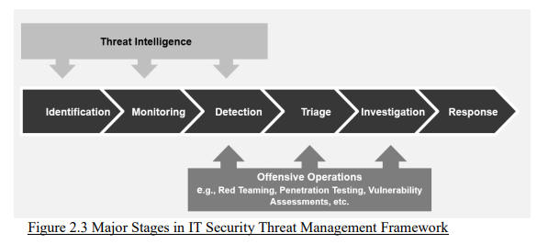

Service Level & Turnaround
Time Range | Description | Expected Turnaround
During office hours | Monday to Friday, 9 AM to 6 PM | 1) PwC on-site analyst should analyze the request with the TI Team, provide a preliminary response within 1 business day upon HKMA’s request.  2) Provide timely updates on HKMA’s request, if necessary.
During non-office hours | The time outside of office hours

NOTE: At times where HKMA makes urgent requests for specific TI, PwC will initially agree the associated turnaround time with HKMA on a case-by-case basis.
In such a scenario, the following are the steps required:
- PwC TI / SOC on-site analyst should immediately inform the Cyber Threat Operations Leads (Jason Lee, Michael Ching) about the request.
- Analyze the request with the TI Team, provide a preliminary response with the agreed SLA upon HKMA’s request.

Step 1)
On working days from 9am to 6pm, the PwC TI on-site analyst will perform continuous monitoring on CVEs and Security Incidents from the Threat Sources.

Day-to-day duties for CVEs sweeping (Collect Data)

i) For CVEs:
Threat Sources to be monitored
- Continuously monitor the PwC mailbox for Critical Vulnerability Alerts (CVAs) sent from "Darklab Threat Intelligence" with the email address darklab.cti@hk.pwc.com.

- Additionally, monitor the “High Threat Security Alert” sent from "GovCERT Subscription/OGCIO" with the email address cert@govcert.gov.hk.

How to monitor Threat Sources
- Inspect incoming emails in these mailboxes to identify any CVE notifications. For PwC CVAs, the CVE number (e.g., CVE-2026-<number>) is located at the end of the email subject.
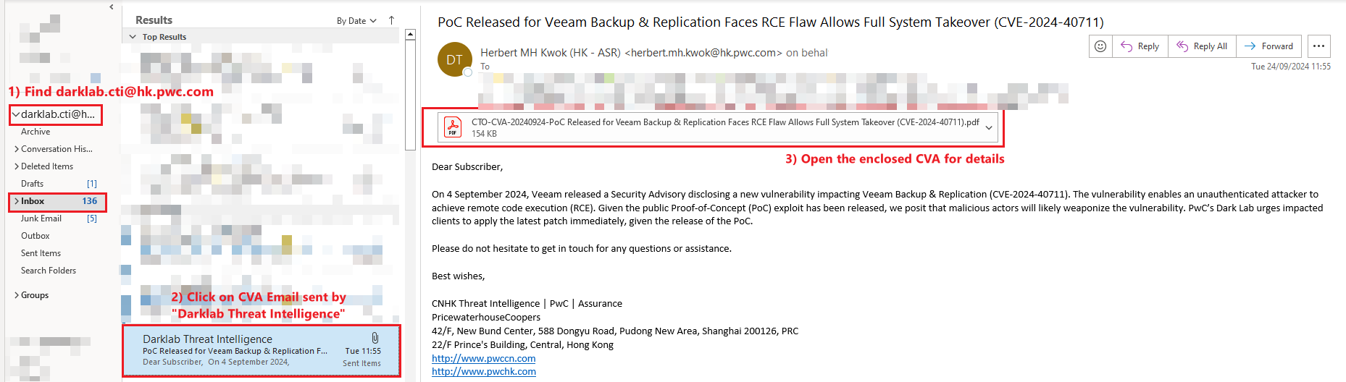
Figure 1: Sample CVAs in PwC’s Outlook mailbox

- For OGCIO CVEs, the email subject begins with "High Threat Security Alert <Date>", with the inclusion of the CVA keyword in the title or summary of the email.

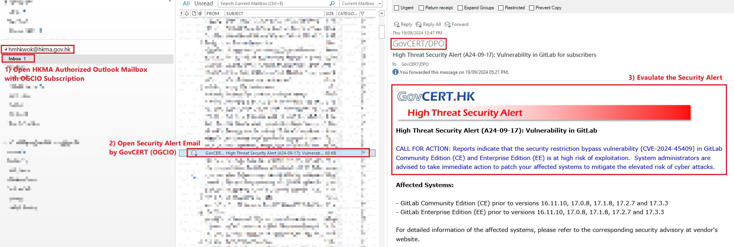

Figure 2: Sample OGCIO Security Threat Alert in HKMA's outlook’s mailbox

ii) For Incidents:

Day-to-day duties for Incidents sweeping (Collect Data)

The TI on-site analyst will perform the following Incident Sweeping including but not limited to “Other Sources” listed in the Appendix:
Intelligence Sweeping | Description
Intelligence from PwC News and Threat Intelligence Portal | 1) The TI on-site analyst should review the PwC News and Threat Intelligence Portal to follow security vendors’ updates, social media trends, as well as intelligence from reputable cybersecurity sources e.g. BleepingComputer, The Register, CyberScoop, etc.  2) The TI on-site analyst should also perform regular monitoring (e.g. hourly) during a business day. The analysis will be based on reports generated within the past 24 hours and their relevance to HKMA in terms of potential threats.
Other Newly Raised Information from PwC’s internal cyber threat operations | Example such as open source, dark web, and proprietary source
Step 2)

Perform Threat Research

The TI on-site analyst should conduct preliminary research based on the discovered CVE / Incident using OSINT and PwC proprietary sources, collect and analyse the research information.

Step 3)
The TI on-site analyst should confirm the relevancy of threat with HKMA by consolidating the researched information, then maps it to the proprietary CVA Criteria: “Capability”, “Intent”, and “Opportunity” as shown below.

3.1) If the threat meets pre-defined criteria (see below) - “Confirming Relevancy of CVE with HKMA” or “Confirming Relevancy of Security Incident with HKMA” section, it is considered to be relevant. The TI on-site analyst should:
- Create (“ITSSOC”) ticket in JIRA Confluence with the component "TI Alert".
- Change the assignee name to be HKMA TI Operation Lead
- Perform Investigation of the threat.
- Update JIRA ticket with findings.
- Proceed to the next step (Step 4).
3.2) Otherwise, the TI on-site analyst should:
- Inform HKMA TI Operation Lead with supporting reason for low relevancy of threat with HKMA.
- If agreed by HKMA TI Operation Lead - terminate at this step.

Note:
#1 As requested by HKMA, if the “High Threat Security Alert” is issued by OGCIO, the TI on-site analyst should follow “Step 3)” above.
#2 The TI on-site analyst should evaluate the relevancy of CVEs / Incidents based on the following pre-defined criteria (see below), which include but are not limited to:

Confirming Relevancy of CVE with HKMA

- Capability

- Attack Vector (e.g., Considering the level of access is required to exploit the vulnerability)
- Attack Complexity (e.g., Considering the ease for attackers to exploit the vulnerability)
- User Interaction (e.g., Whether exploitation require user execution)

- Intent

- Active exploitation in the wild (i.e., The vulnerability has been observed to be exploited by threat actors)
- Relevant reporting in the source that PwC TI on-site analyst to check regarding to CVEs

Source Checking | Purpose
OSINT | When multiple researchers report a CVE, it suggests a higher likelihood of it being a critical vulnerability and more prone to exploitation.
Dark Web | Checking for any references to the CVE (e.g., Threat actors selling Proof of Concept (PoC) or requesting exploit codes)
Social Media | Monitoring discussions on platforms like Twitter helps assess public perception, indicating the criticality the vulnerability.

- Opportunity

- CvSS v3 score
- Whether it is Actively Exploited in the Wild
- PwC Client Product Coverage – Known use by other SOC client
- Possibility of matching to one of the reference
1) Technology Stack Reference – Provided by HKMA AI Team
2) Tenable Security Center – Provided by HKMA CVM Team

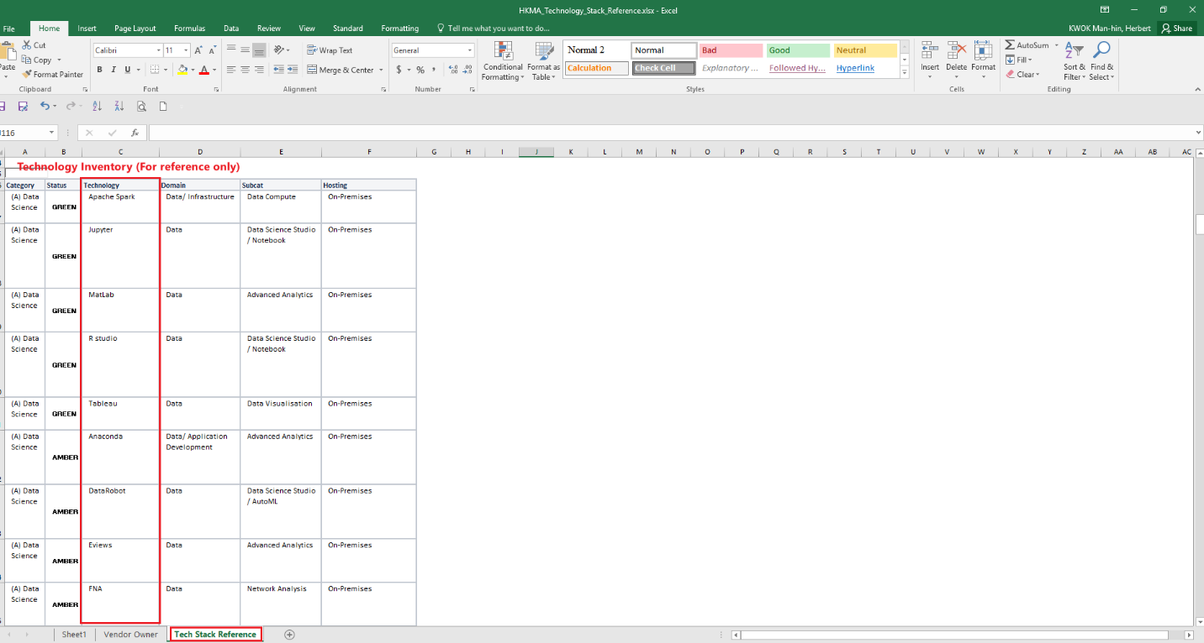
Figure 3: Technology Stack Reference (In Excel Format)
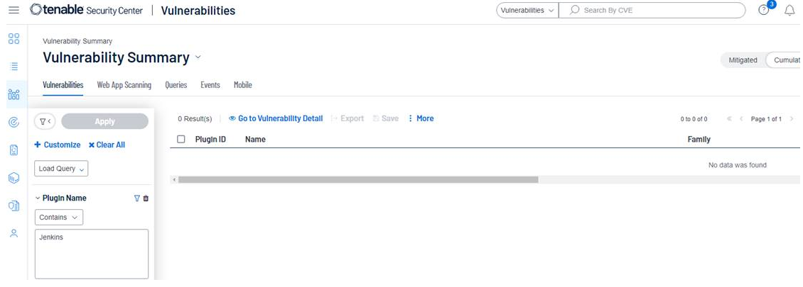
Figure 4: Tenable Security Center

If there is no match, the TI on-site analyst should write the following as a Jira comment.
Type | Content of Request for Ticket Closure in Jira
Ticket | "Ticket is closed. Based on the result from Tenable, none of the above listed CVEs are found in our asset list."

Step 4)
The TI on-site analyst will perform Case Categorization and Determine Internet-Facing (both detailed below) and include the findings in JIRA.

Case Categorization

The TI on-site analyst categorizes the threat into relevant categories:
- Social threats (e.g., social engineering attacks, phishing)
- Technical Threats (e.g., Malware, zero-day exploits)
- Environmental Threats (e.g., hardware failures, outage)
- Others (e.g., threat landscape)
Within each category, the analyst should define specific threat types as comprehensively as possible.

Pre-Agreed Definition of Internet-Facing

An “Internet-Facing System” refers to any system or service that has a public IP address and is accessible from the Internet. This includes, but is not limited to:
- Firewall-based systems (e.g., Web Application Firewalls (WAF))
- Public-facing web applications (e.g., https://vpr.hkma.gov.hk)
Note: Refer to the file “Inventory record for CVM Total.xlsx” (provided by the HKMA CVM Team) to determine whether a system falls under the following categories:
- Internet-facing (most critical)
- GNET
- DMZ
- OA network
- SWIFT

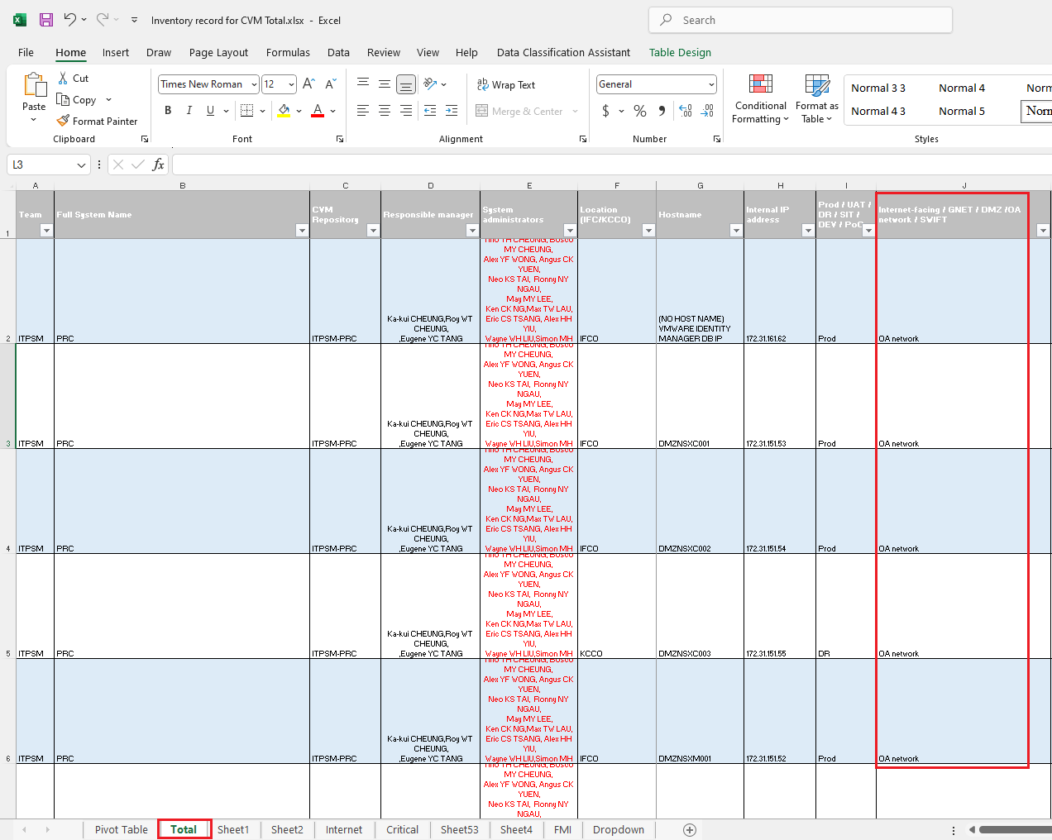

Figure 5: Inventory record for CVM Total.xlsx

Threat Severity Classification (Adopted by HKMA)

The TI on-site analyst should reference multiple sources to and use the Threat Classification Matrix to determine the Final Severity Level (Critical / High / Medium) of vulnerability. Follow the Standard released by public sources, including i) vendors, ii) DPO, and iii) NVD.

Threat Classification Matrix (Based on CVSS v3; Adopted by HKMA)

CVSS v3 Score Range | Severity Level
9.0 – 10.0 | Critical
7.0 – 8.9 | High
0.1 – 6.9 | Medium

Note: In the last endorsed TI Playbook – includes below section purposed by PwC; but not Adopted by HKMA:
- PwC Proprietary “Define Threat Severity” - Link to appendix
- PwC Proprietary “Threat Classification Matrix” - Link to appendix

Step 5)
The TI on-site analyst obtains the Final Severity Level of the CVE in step 4) above. Then, the following actions should be taken based on the Final Severity Level of vulnerability (Critical / High / Medium / Low)
Final Severity Level of CVE | Critical | High | Medium | Low
Follow-up Actions by PwC TI on-site analyst
Document Findings in JIRA | ✔ | ✔ | ✔ | ✔
Email HKMA System Owners via Outlook to Confirm System is Affected  If Confirm Affected:  - Route the JIRA ticket to HKMA system owners  - Verify Remediation Result, updated to sub-ticket | ✔ | ✔
Follow-up Actions by HKMA
If necessary, HKMA SOC Manager immediately communicates with responsible parties | ✔ | ✔
System Owner replies email - confirms if system is affected, and provide remediation plan | ✔ | ✔
Expected Turnaround from System Owner | TBC | TBC

Figure 5: Follow-up Actions Based on Final Severity Level of CVE

TI on-site analysts and HKMA should take follow-up actions accordingly, referencing the table above. Detailed follow-up actions are as follows:

Process #1 - Critical / High Severity CVE

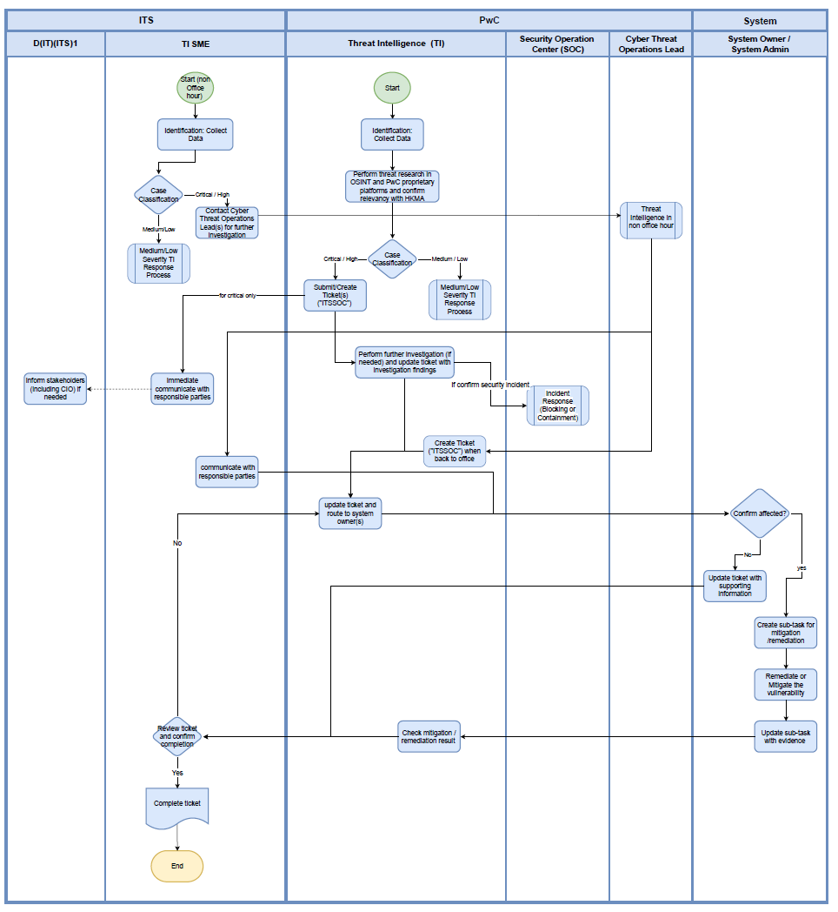

Jira Handling

The TI on-site analyst should enclose the attachment(s) if any, then document the findings to update the ticket in JIRA (See following steps).
a) Enclosed OGCIO Threat Alert Email if any
b) Enclosed PwC proprietary Critical Vulnerability Alert (CVA) source issued by PwC's Threat Intelligence team if any (See below)
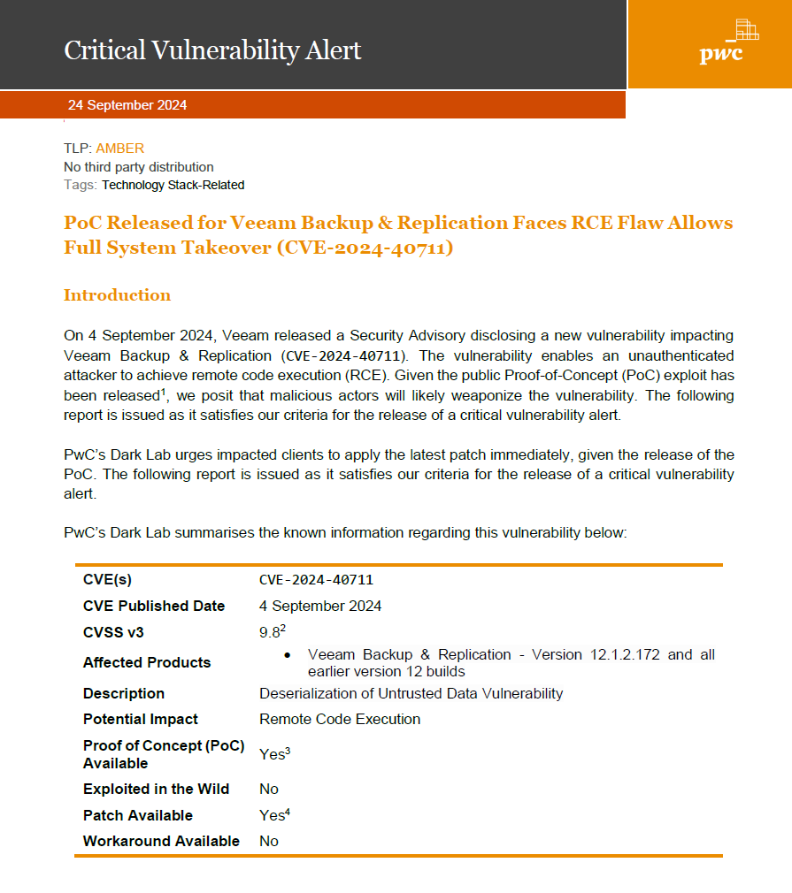
Figure 6: Critical Vulnerability Alert (CVA)
c) Background of the CVE
Include an identification number CVE-yyyy-xxxx, where yyyy stands for the year and xxxx is a unique identifier.
d) Summary of the CVE
Provide a brief overview of the vulnerability.
e) Potential Impact of the CVE
Evaluate the potential impact the vulnerability brings.
f) Affected Product and Its Version
Specify the affected product and its version as indicated by each CVE entry.
g) Recommendations / Suggestions Provided by PwC
Mainly suggest patch management. Document the email communications in the JIRA ticket (Reference Below)

Email Handling to HKMA System Owners

Template for Email
Template

Subject: [Urgent] [%CVE Identifier%] %CVE Title%
Dear all,
This is to notify you that %Vendor Name% has released an official advisory and patches to remediate %CVE Identifier% for potentially affected %Affected Product Name% Instances.
Attribute |  | Details
Name |  | [%CVE Identifier%] %CVE Title%
CVSS v3 Score |  | %CVSS v3 Score%
Exploitation Metrics | Exploited in the Wild  (Attackers are already leveraging the vulnerability) | %Yes or No?%
 | Exploitable | %Yes or No?%
 | Remotely Exploitable | %Yes or No?%
 | Exploitable by Non-Privileged Accounts | %Yes or No?%
System Known to be Widely Used |  | %Yes or No?%
Affected Version(s) |  | %Versions of Products%
Impact |  | %Type of Vulnerability% enables attacker to %Consequence%.
Final Severity Level |  | High
Action(s) |  | Please reply to this email if you confirm your system(s) are affected.  We suggest following the Fortinet Advisory to apply the patch or workaround.
Reference(s) |  | Vendor Security Advisory (with hyperlink)  Tenable for CVE (with hyperlink)

CVE Notification Email – Recipient Criteria
The TI On-site Analyst is responsible for sending CVE notification emails. All Associate Directors (ADs) must be included in every CVE notification email.
To: Recipients (IT Teams to Notify)
Product Category | IT Team to Notify
Network / Network Firewall | ITIS Network Infrastructure
PSO | ITIS Network Infrastructure
Application | AS1 / AS2 / DP / AI / FMI / CMU / DPB
Database | AS1 / AS2 / DP / AI / FMI / CMU / DPB
Platform / OS | All teams
Notify the appropriate IT team(s) based on the affected product(s):
Cc: Recipients (Always include)
- FMI
- HKDPB

Due Date for System Owner to Reply
To be further discussed end May.

Follow-up Actions by System Owner / TI on-site analyst - if affected by vulnerability
5.1) Follow-up actions by System Owner
System Owner provide the following information (included in CVE email communication sent by TI):
- Internet Facing (Yes / No)
- Affected System / Server IP(s)
- Target Solution Apply / Patch Date
System Owners are expected to initiate remediation.
5.2) Follow-up actions by TI on-site analyst
#1 TI on-site analyst then assigns JIRA ticket to the System Owner to coordinate the necessary patching and tracking.
#2 System Owner initiates remediation, TI on-site analyst help update JIRA ticket with evidence of remediation (e.g., screenshot).
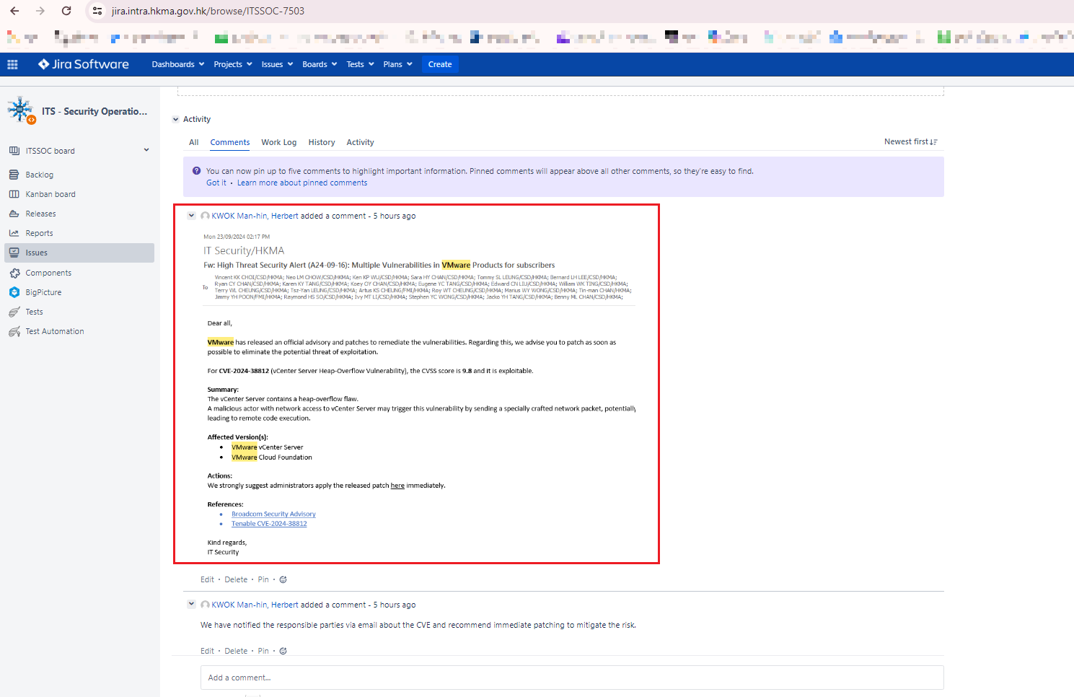
Figure 7: Sample of attaching the screenshot of the sent notification email

Route the JIRA ticket to HKMA System Owners

The TI on-site analyst should change the Assignee to be the name of HKMA System Owner(s) who is/are adapting the potentially affected system, then the ticket will be created with the following points:
- Add "[TI alert escalation]" to the front of the ticket title.
- Set the ticket component as "TI alert escalation."
- Set the assignee to be the according stakeholder.
- Set the status of the sub-ticket as "In progress."
- Attach the supporting information to the ticket, or OGCIO Email Alert where applicable.
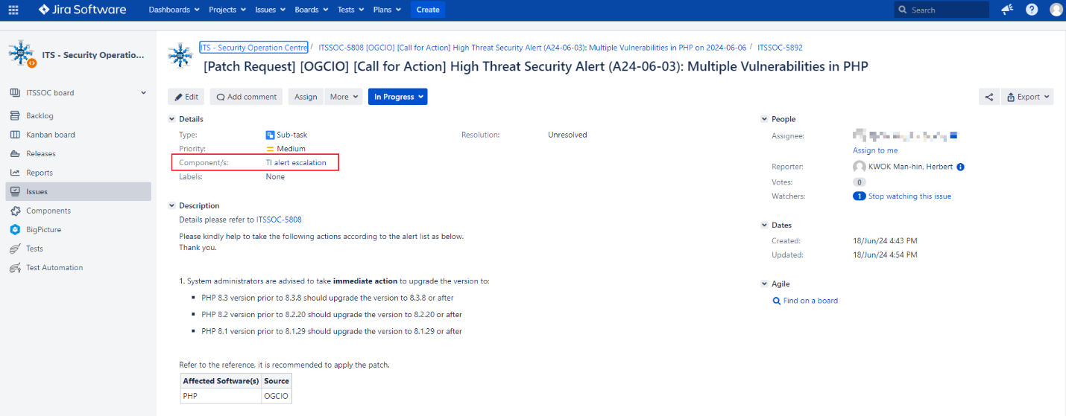
Figure 8: Sample template of assigning JIRA ticket to stakeholder(s)

TI Verify Remediation Result

TI on-site analyst verifies the remediation evidence by System Owner in sub-ticket, ensuring the patched version has remediated the vulnerability.
The TI on-site analyst then marks the sub-ticket’s status as “Done,” includes a justification in the sub-ticket, and seeks approval for sub-ticket closure from AD(IT)(ITS)3.
The following is a reference for comments in the JIRA ticket/sub-ticket. Additional details can be added if applicable:

[Jira Template] Ticket / Sub-ticket Closure Comment
Type | Content of Request
Ticket | "The ticket is closed as confirmed there is no system owner leveraging the affected version of the system for past two weeks."  OR  "The ticket is closed as confirmed all system owner leveraging the affected version of the system has completed the patch for past %Patching duration%."
Sub-ticket | "The ticket is closed as confirmed %System owner name% has completed the patch."

Process #2 - Medium / Low Severity CVE Processing

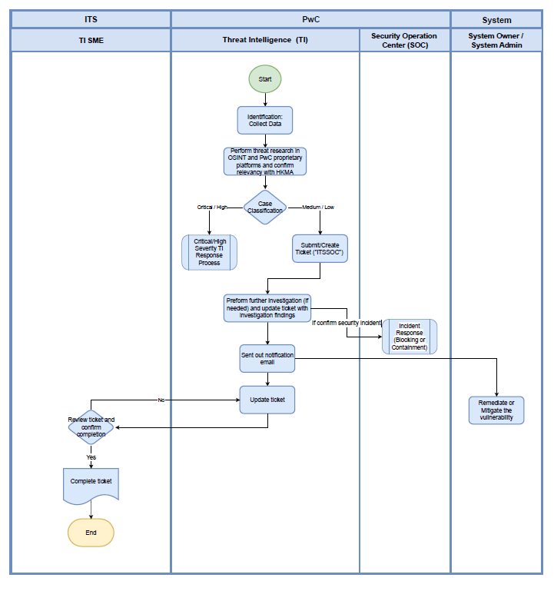

Jira Handling

Same Procedure as “Critical / High Severity CVE Processing”.
For more details, please refer to the above “Jira Handling”.

Email Handling to HKMA system owners

The TI on-site analyst will not send email notifications for medium- or low-severity cases, unless an exception is approved by the HKMA SOC Operations Lead or SOC Manager.

c) Security Incident Processing

Confirming Relevancy of Security Incident with HKMA

- Assessing the relevance of the incident against HKMA (e.g., Potential match with HKMA’s basic Inventory List on technology)

- Assessing the relevance of the incident to Hong Kong

- Assessing the relevance of the incident with respect to whether the industry is typically recognized globally and/or locally as a critical infrastructure operator (e.g., Singapore Cyber Security Act may have a list of Essential Services)

- Assessing the relevance of the incident to specific industries that are relevant to HKMA (e.g., Global Central Banks, Fintech, Financial Services, and Property Development, etc.)

- If PwC cannot find any publicly available information regarding the incident or if the incident has not been publicly disclosed, PwC will provide the findings of their analysis (if any) to HKMA via email including relevant case studies of incident experiences, where applicable

- HKMA provides the information on IOC to PwC TI / SOC on-site analyst for further investigation

- Upon request by HKMA, PwC will provide a summary regarding publicly reported incidents based on their understanding from OSINT, and the expected turnaround is as follows:

Perform Further Investigation and Document Findings of Security Incident in the Jira ticket

i) Preliminary Findings Summary by TI On-Site Analyst

The TI on-site analyst compiles preliminary findings from OSINT, social media, and security data sources (e.g., VirusTotal, URLscan.io, AbuseIPDB) using the following proprietary template:

[Analysis Template] OSINT Sweeping

Name | Description
IP/Domain/URL to be investigated | N/A
Confidence | Confidence level
Traffic Light Protocol (TLP) | %Red/Amber/Green/White%  Each colour represents for how the information should be handled.:  i) Red: The most sensitive and should only be shared within the organization on a need-to-know basis.  ii) Amber: information that should be shared within the organization and with trusted partners.  iii) Green: information that can be shared more widely  iv) White: information that can be publicly shared
Target Sector | Sector/Industry that involved
Target Country | N/A
Identified Threat Actor (TA) | Individuals or groups that intentionally cause harm to digital devices or systems
Threat Actor Type | Industry of Threat Actor, if applicable
Tactics, Techniques & Procedures (TTP) | Search for the name and the ID of attack technique which are involved in the incident in MITRE ATT&CK framework.
Indicators of Attack (IOAs) | Example:  Unexpected login attempts  Unusual network traffic  Suspicious file downloads
Indicators of Compromise (IOCs) | Example:  Malicious IP/Domain/URL/signature/hash

[Analysis Sample] OSINT Sweeping
Sample
Source: OSINT
Confidence: High
TLP: AMBER
Target Sector: Supply Chain
Target Country: Worldwide
Identified TA: China-based CDN company "Funnull"
Threat Actor Type: Information technology
TTP: T1059 - Command and Scripting Interpreter
IOA: N/A
IOC: %IP/URL/Domain/Signature/Hash%

ii) In-Depth Investigation by TI On-Site Analyst

The TI on-site analyst collaborates with the TI team for a comprehensive investigation to identify any malicious IP(s) or domain(s) and assess their potential indication of a targeted attack. The following factors should be considered, where applicable:
- Pivoting on fingerprints / thumbprints of other malicious domains that may be impersonated by the same threat actor
- Determine if the malicious domain shares the same IP address
- Assess if the domain registration is recent / young
- Conduct source code analysis, particularly for domains applicable to webpages (e.g., Look for redirected pages and assess their purpose)
- Determine the intention of the threat actor behind the identified activity
- If applicable, include relevant case studies of incident experiences where there is insufficient public and PwC source information, such as cases without IOCs or identified threat actors.

d) Monthly Statistics & Report for OGCIO Security Alerts

HKMA Monthly Report
For the HKMA Monthly Report, the following statistics will be included:
- Communications/Settlement Phishing Emails
- Threat Hunts
- OGCIO High Threat Security Alerts
- PwC Proprietary Critical Vulnerability Alerts
- SOP Status of Operational Intelligence
- Major Threat Intelligence Report Highlight & Executive Summary
- Threat Intelligence Report List

OGCIO Security Alerts
1) Access the HKMA internal Sharepoint named SOC Filing Database.
2) Click on “3.1 High Threat Security Alert Monitoring (2024 March Start) – New”.
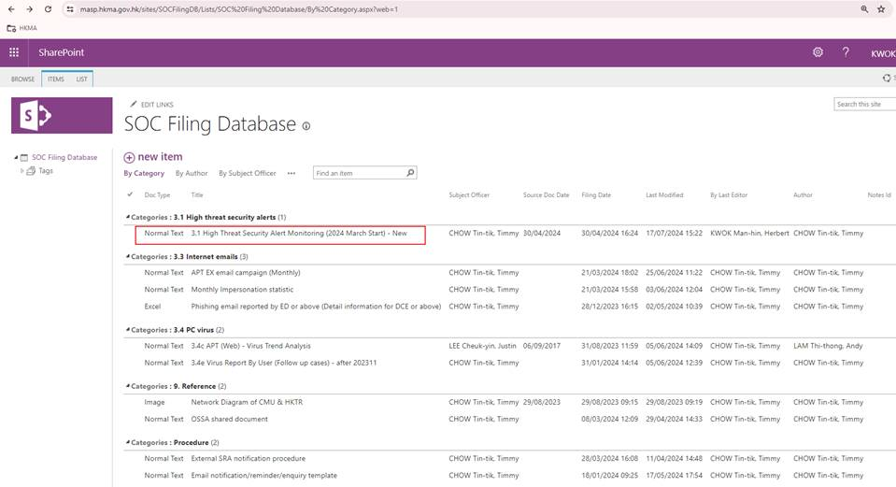

3.1) Fill in the total number of cases for OGCIO security alerts that require "Call for returns", "Call for actions", and immediate review.
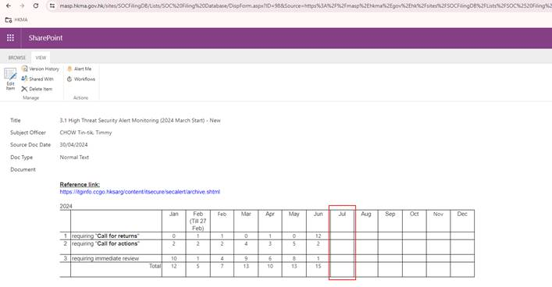
3.2) Fill in the information for each security alert in the corresponding columns.
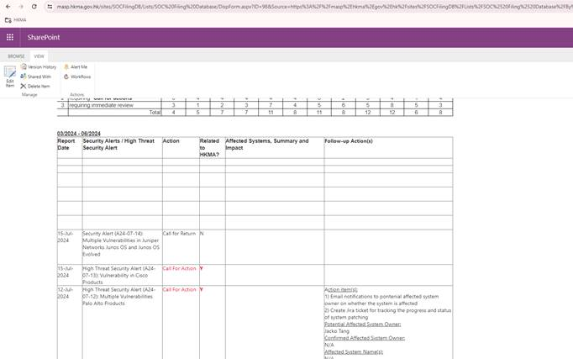

Suggested Template for Threat Monitoring Table
Template

Report Date | Security Alerts / High Threat Security Alerts | Action | Related to HKMA? | Affected Systems, Summary, and Impact | Follow-up Actions
​%dd-mmm-yyyy%​​ | ​%Security alert title% | ​%Call For Action / Call For Return / Immediate Review% | ​%Y / N% | ​ | ​(If applicable)  Action item(s):  1) Email notifications to potential affected system owner on whether the system is affected  2) Create Jira ticket for tracking the progress and status of system patching  Potential Affected System Owner: %Name / N/A%  Confirmed Affected System Owner: %Name / N/A%  Affected System Name(s): %Name / N/A%  Patched? %Y / N%  Jira Ticket Status: %Done / In progress / N/A%

4) For information on OGCIO security alerts or high threat security alerts, please refer to the IT Security Theme by the Government Information Station. The below screenshot is for reference.

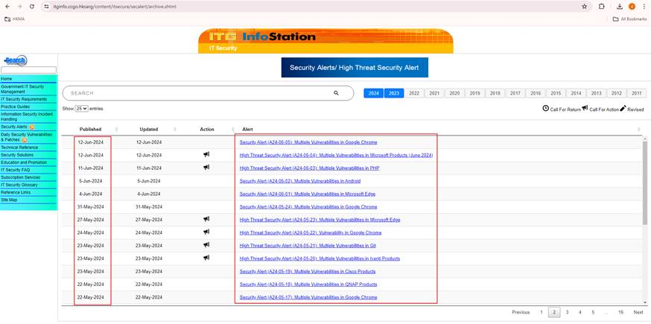

e) Dark Web Monitoring (DWM) Alerts Handling

i) Alert Monitoring
On working days at 10:00 AM and 4:00 PM, the TI on-site analyst will monitor “HKMA - Leaked Credentials” alerts from Dark Web Monitoring (DWM) in the PwC JIRA Platform, as shown in the screenshot.
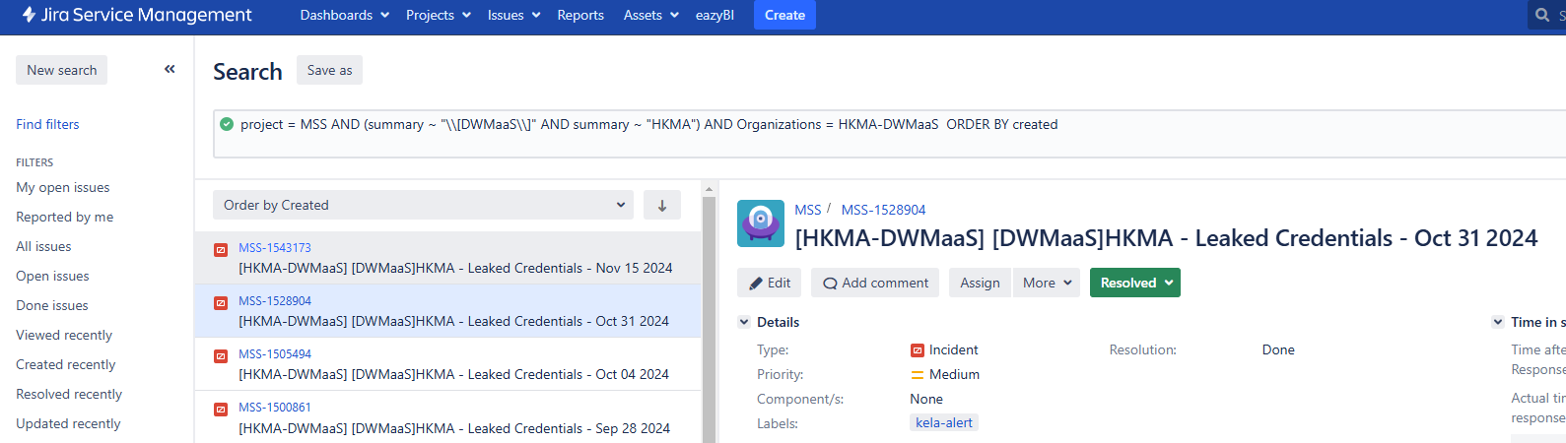

ii) Ticket Creation
If a dark web monitoring alert ticket is found in the PwC JIRA Platform, the TI on-site analyst will create a corresponding JIRA ticket in the HKMA platform with the following details:
- Title: Add "[TI Dark Web]" to the front of the ticket title.
- Component: Set the ticket component as "TI Alert".
- Status: Set the status of the sub-ticket as "In progress".

iii) Findings by TI on-site analyst
The TI on-site analyst should copy the content of the relevant ticket from the PwC JIRA Platform and paste it into the HKMA JIRA Platform. Below is an example template:
Template

==Background==
Our Cyber Threat Intelligence investigated the incident and found %Count% Leaked Credential related to your organisation exposed in dark web. The credentials are listed below:
As per our open-source investigation through passive means, we observe that:​
EMAIL | DOMAIN | PASSWORD | SOURCE | POSTED DATE | SERVICE

%Source Name% Credentials automatically extracted from various Telegram channels.
We recommend confirming that the service coverage is to customers only, or whether it also includes staff and/or third-party, and evaluate if accounts with administrative privileges require a password change. We also recommend to heighten monitoring of customer login to indicate anomalies in location or timing, and review password policies and evaluate if there is a need to strengthen (e.g., mandate password rotation regularly). A further recommendation is to reach out to these account holders if the accounts are still active, and request that they change their passwords.​

iv) Further follow-up by TI on-site analyst, if applicable
- Scenario: No update in the ticket within 1 business day
  - The TI on-site analyst will comment in the JIRA ticket follow the template below, and contact AD(IT)(ITS)3, using the template below.
Template

Dear Customer,
May we know if you have an update regarding this case? We look forward to hearing from you. Thank you.
This is a reminder. If you have already responded to this alert, please ignore this reminder and sorry for the inconvenience caused.
Best Regards,
TI on-site analyst

- Scenario: AD(IT)(ITS)3 has any concerns or ad-hoc requests
  - The TI on-site analyst will coordinate with Tier 2 PwC Threat Intelligence (TI) colleagues, and update AD(IT)(ITS)3 once new information is available.

v) Ticket Closure
AD(IT)(ITS)3 reviews ticket and confirm completion, closes the ticket.

f) HKMA Domain Monitoring / Domain Impersonation

i) Alert Monitoring
On working days at 10:00 AM and 4:00 PM, the TI on-site analyst will monitor the HKMA domain (hkma.gov.hk) using search feeds on social media and a malware database to cover social media monitoring, as shown in the table below.
Use case | Source | Frequency | Search Query | Output sample
Search feeds on social media | https://x.com/ | Daily (10am, 4pm) | Example:  "HKMA" AND (#mirai OR #RAT OR #RedLineStealer OR #cobaltstrike OR #NjRAT OR #qakbot OR #asyncrat OR #DCRat OR #Guildma OR #geo)  Then Click “Latest” to make sure the information is the latest.  Note: The selected tags are the top 10 malware families from threatfox.abuse.ch. We will include more malware families as required, but this approach allows us to be focused while also reducing large volume of false positives. | 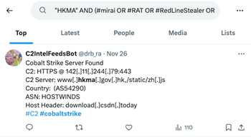
Search feeds on malware database | https://threatfox.abuse.ch/ | Daily (10am, 4pm) | Example:  ioc: hkma.gov.hk  Note: While this includes the user drb_ra which we assessed was how HSBC identified and notified BSD, we observed that the abuse.ch integration is not always accurate. As a result, this is also required to work together with use case no.1. https://threatfox.abuse.ch/user/11122/ | 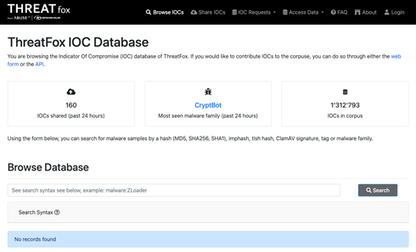

ii) Ticket Creation
If search feeds for keywords are found, the TI on-site analyst will create a corresponding JIRA ticket in the HKMA platform with the following details:
- Title: Add "[TI] [Spoofing Domain]” to the front of the ticket title.
- Priority: Set as “High”.
- Component: Set the ticket component as "TI Alert".
- Status: Set the status of the sub-ticket as "In progress".
If there are any new findings, the TI on-site analyst will document them in the JIRA ticket, escalate it to HKMA AD(IT)(ITS)3, PwC Michael, Jason, and Wendy to determine if Incident Response (IR) is necessary.

iii) Email Outreach – Domain Spoofing HKMA
Template
Subject: Fraudulent Domain Spoofing HKMA – [Spoofing Domain]

Dear HKMA Team,
We would like to share a recently observed spoofing page for HKMA from our Young Domain Scanner. Detailed documented in ITSSOC-xxxxx.
Technical Indicators of Compromise (IOCs):
[Document your Spoofing Domain]
Sample Screenshot (Phishing Page):
[Provide Screenshot of your Spoofing Domain]
Recommendations
#1 Reviewing your environment for any correlated traffic to this domain (e.g., identify potential credential submissions)
#2 Immediate blocking of fraudulent URL(s) at your proxy
#3 Take down suspicious URLs

iii) Email Outreach – Domain Spoofing other Banking / Financial Institution
Template
Subject: Fraudulent Domain Spoofing [Targeted Bank] – [Spoofing Domain]

Dear HKMA Team,
We would like to share a recently observed spoofing page targeting the following institutions, detected from our Young Domain Scanner on [Date]. Detailed documented in ITSSOC-xxxxx.
Technical Indicators of Compromise (IOCs):
[Document your Spoofing Domain]
Sample Screenshot (Phishing Page):
[Provide Screenshot of your Spoofing Domain]
Recommendations
#1 Reviewing your environment for any correlated traffic to this domain (e.g., identify potential credential submissions)
#2 Immediate blocking of fraudulent URL(s) at your proxy
#3 Report any fraudulent domain to relevant stakeholders

g) Phishing Email Handling

i) Reported Email Analysis

On working days, the TI on-site analyst will initiate the investigation on the email reported by the HKMA Communications & Settlement Team. This email is sent from the HKMA IT Helpdesk via the HKMA IT Security Mailbox (i.e., its-operations@hkma.gov.hk).

ii) Reported Email Category
The major classified types are as follows:
- Spam: Appears to be promotional/advertising/financial purpose or lures the user for an instant reply.
- Phishing: Involves credential harvesting or malware.

For detailed procedures, please refer to the Phishing Email Handling Guideline titled “User Guide on creating Jira ticket for handling phishing email incident (Settlement and Communications) case.docx”. This document is available in the SOC Filing Database hosted internally at HKMA.

2) Threat Hunting

Objectives of Threat Hunting

Below are the examples of objectives mapped with Threat Hunting Scenario:
Outcome(s) | Threat Hunting Scenarios | Source(s)
Determine if the email poses a threat to HKMA or its stakeholders. | Malicious Emails | Security incidents
Determine appropriate actions to mitigate the risks associated with impersonation incidents.  Evaluate the potential impact of the impersonation attempts. | Impersonation of HKMA | PwC CTO output, CVEs
Consider outcomes of discussions with HKMA, that require the threat hunting activities. | Requirements based on discussion agree with HKMA | Case-by-case, per discussions with HKMA
Ensure whether users had run the unblocked malware in HKMA computer by Threat Hunting in Splunk, and other EDR Solutions | User Interactions - Identification of HKMA users run malware | JIRA Ticket provided by PwC SOC

Scope of Threat Hunting

Below is the Threat Hunting Scope, agreed with HKMA, including but not limited to:
HKMA Related:
- Malware in malicious emails (ED or above, Communications, Settlement Team)
- Malware found on any HKMA device provided by SOC, which is responsible for creating a ticket and assigning a sub-ticket to TI
Regional Focus:
- China / HK / Macau Related
CVE / Vulnerabilities:
- CVE / Vulnerabilities targeting HKMA technology-related tools
Technology Related:
- HKMA Technology (e.g., Payload / malware download compromising HKMA tools)
PwC Proprietary Cyber Threat Intelligence Weekly Report:
- Included any IoCs
Opportunistic Advanced Persistent Threat (APT) Group:
- Included the IoCs in APT Groups’ latest campaign based on their latest activities

Trend-Related Threats (Not limited but include the following):
- Remote Access Tools
- InfoStealers
 | Threat Actors Group
Remote Access Tool | Medusa | Rhysida | Mad Liberator | Cactus | Lockbit | MuddyWater (TA450) | LilacSquid | Awaken Likho | Tur0k | Black Basta (Storm-1811) | Bezenchuk | FIN7 (Carbanak) | Bl00dy | RansomHub | BianLian
AnyDesk | ✓ | ✓ | ✓ | ✓ | ✓
Atera Agent |  |  |  |  |  | ✓
MeshAgent |  |  |  |  |  |  | ✓ | ✓ | ✓
QuickAssist |  |  |  |  |  |  |  |  |  | ✓ | ✓
NetSupport Manager |  |  |  |  |  |  |  |  |  |  |  | ✓
ScreenConnect |  |  |  |  | ✓ |  |  |  |  | ✓ |  |  | ✓
Splashtop |  |  |  | ✓ |  |  |  |  |  |  |  |  |  | ✓ | ✓
TeamViewer |  |  |  |  | ✓

2.1) Ticket Creation for Threat Hunting
In the HKMA JIRA environment, TI on-site analyst will create a Jira ticket for the threat hunting process.
- Ticket component: “TI Threat Hunt”
- Ticket title: [TI] [Threat Hunt] [Name of Affected Product, if any] %CVE / Incident Name%
- Ticket content: Include but not limited to the findings of threat and IoCs (See below steps)

2.2) Evaluation of Threat Hunting
The TI on-site analysts should refer to the following sources to assess the threat hunt:
- Open-source security research blogs (pre-defined by PwC)
- OGCIO High Threat Security Alert Email
- CVAs received in PwC’s Darklab Threat Intelligence Mailbox, OR
- Other PwC’s proprietary source
The evaluation should be conducted in accordance with the “Scope of Threat Hunting” as above outlined.

2.3) Threat Actor Summary
In the event of identifying a threat actor during a threat hunting case, the TI on-site analyst should conduct a Threat Actor Summary to gather and reference potential threat actors for further information. The following details should be included, if available (if not, fill in N/A):
- Aliases
- Country of Origin
- Known Targets
- Active Since
- Target Sectors
- Primary Objectives
- Techniques

2.4) Collect Findings to Utilize in JIRA ticket
Key Takeaways: Key points or summaries listed in OSINT sources, selected by the TI on-site analyst.
Indicators of Compromise (IoCs): Collect IoCs from credible sources in OSINT, VirusTotal, social media, etc.

2.5) Approval to Perform Threat Hunting
The TI on-site analyst should obtain HKMA SOC Operation Lead approval for threat hunting.
Use Case
Step 1 - TI on-site analyst comments:
[Name of HKMA SOC Operation Lead] May I have your approval to proceed with threat hunt the malicious indicators in Splunk? Thank you.
Step 2 - HKMA SOC Operation Lead comments:
Approved to proceed with threat hunt.
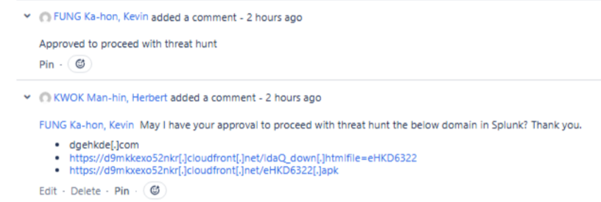

2.6) Perform Threat Hunting on HKMA Security Solutions
The coverage of finding Indicators of Compromise (IoCs) for threat hunting in security solutions, as originally intended for SOC monitoring log sources in HKMA, is as follows:
Threat Hunt Security Solutions | Index | Description | IoCs
 |  |  | IP | Domain | URL | Hash
Splunk | soc_forcepoint | Proxy-Level | ✔ | ✔ | ✔
 | soc_fireeye |  | ✔ | ✔ | ✔ | ✔
 | soc_darktrace |  | ✔ | ✔ | ✔
 | soc_cisco_fp | NIPS-Level | ✔ | ✔ | ✔
 | soc_paloalto |  | ✔ | ✔ | ✔
 | soc_cisco_asa |  | ✔ | ✔ | ✔
 | soc_fortinet | NIPS-Level | ✔ | ✔ | ✔ | ✔
 | soc_axway |  | ✔ | ✔ | ✔
 | soc_imperva | WAF-Level | ✔ | ✔ | ✔
 | soc_f5 |  | ✔ | ✔ | ✔
 | soc_symantec |  | ✔ | ✔ | ✔
 | hkma_infoblox |  | ✔ | ✔ | ✔
 | hkma_windows |  | ✔ | ✔ | ✔
SentinelOne | N/A | EDR-Level |  |  |  | ✔

2.7) SOC Standardized Threat Hunt Query
To perform TI/SOC threat hunting, below standardized queries are used (Replace the strings in red based on your search condition):
- Network traffics (Splunk)
index IN (soc_*, hkma_*) <IP> OR <Domain>
| eval Source_IP=coalesce(src, srcip, src_ip)
| eval Source_Port=coalesce(srcport, src_port)
| eval Destination_IP=coalesce(dest, dstip, dest_ip, dst)
| eval Destination_Port=coalesce(dstport, dest_port)
| table _time index sourcetype host Source_IP Source_Port Destination_IP Destination_Port _raw
| sort -_time

- File Hash SHA-256 (Splunk)
(index=soc_fireeye OR index=soc_fortinet) <hash>
| eval Source_IP=coalesce(src, srcip, src_ip)
| eval Destination_IP=coalesce(dest, dstip, dest_ip, dst)
| rename flexString1 as sha256_fireeye
| table _time Source_IP suser Destination_IP duser sha256_raw

- File Hash SHA-1 (EDR - SentinelOne)
TgtFileSha1 = "hash" OR TgtProcImageSha1 IN ("hash")
OR SrcProcImageSha1 IN ("hash")

- Command execution (Splunk)
((index=hkma_windows AND EventCode IN (4688, 4103, 4104)) OR index=hkma_nix) <Process> OR <Command>
| table _time index sourcetype ComputerName Creator_Process_Name New_Process_Name Process_Command_Line _raw
| sort -_time

- Command execution (EDR - SentinelOne)
SrcProcCmdLine Contains "process"

2.8) Validate the findings of Indicators / Hits
If an Indicator of Compromise (IOC) is discovered during a threat hunt and matches an IOC found within the HKMA internal systems, it indicates the presence of an identified threat.
The TI on-site analyst should next determine whether the hit is a False Positive / True Positive with low/medium severity / True Positive with high severity. Appropriate actions for investigation and mitigation will then be initiated, as outlined in the following table:
Hits | Condition(s) | Inform AD(IT)(ITS)3? | Further follow-up | Descriptions
False Positive | Legitimate File or Domain | Yes | Explain the reason why the hit is a false positive in the JIRA ticket. | Determine if the user has the permission allow to use the legitimate file / access legitimate domain.
True Positive with low/medium severity | 1) TI Feed reported suspicious activity  2) The collected evidence is not correlated to Threat Actor or a C2 Server | Yes | Collaborate with SOC on-site analyst to perform searches in the source for further analysis and detection. | TI on-site analyst shares the Threat Hunting case listed in Jira ticket to SOC on-site analyst.
True Positive with high severity | 1) Already Compromised  2) The collected evidence is correlated to Threat Actor and/or a C2 Server  Common case Example: Web Shell | Yes | Discuss with HKMA if necessitate to trigger Incident Response. | Please refer to the section 4 Incident Response.

Below is the detailed process for handling the security hits:
- Research IP Purpose: TI should investigate the purpose of the IP (e.g., Command and Control (C2), Distributed Denial-of-Service (DDoS), Malware Distribution, Phishing, etc.) and relay this information to the SOC.
- Confirm APT Targeting:
  - Verify the attack period by the threat actor using HKMA security solutions.
  - Determine if the Indicators of Compromise (IoCs) are associated with an Advanced Persistent Threat (APT) group, as documented in reputable researchers' blog posts.
  - Review reports on the IP address obtained through OSINT and social media.
- Update Severity Level: TI should escalate the JIRA ticket's severity level to 'critical' if confirm APT Targeting.

2.9) Approval to Request Block Indicators
The TI on-site analyst should obtain HKMA SOC Operation Lead approval for requesting blocking of indicators.
Use Case
Step 1 - TI on-site analyst uploads screenshot(s) of threat hunt results (e.g., Splunk / SentinelOne).
Step 2 - TI on-site analyst comments:
[Name of HKMA SOC Operation Lead] May I have your approval to proceed with request blocking the malicious indicators? Thank you.
Step 3 - HKMA SOC Operation Lead comments:
Approved to proceed with blocking.
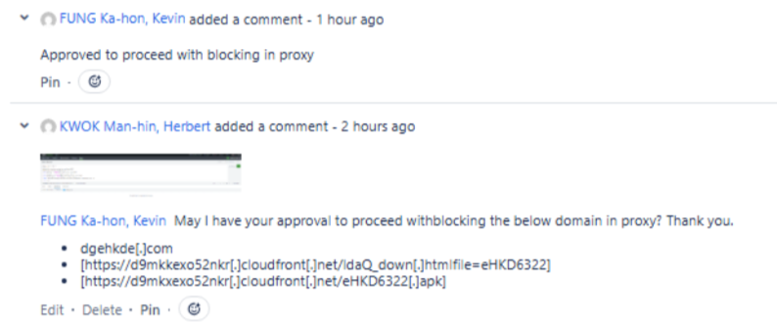

2.10) Create sub-ticket to request blocking the IoCs found via Threat Hunting
The TI on-site analyst should obtain HKMA SOC Operation Lead approval, to request blocking validated IOCs, if any, based on their types indicating below.
Ensure the severity level of each sub-ticket is flagged as 'critical' if confirm APT Targeting. As agreed by HKMA, for ‘critical’ cases, the IoCs should be blocked within one business day.

Block Category 1 – URL / Domain in Proxy
a) The TI on-site analyst should block the domain in proxy by creating a sub-ticket with the title prefixed by "[Block request for proxy].”
b) Set the ticket component as "Block request for proxy."
c) Set the status of the sub-ticket as "In progress."
d) Use the sample template provided below for the sub-ticket in Jira.

[Jira Template] Request on blocking IoCs with Domains in Proxy
Template

This request is approved. Details please refer to ITSSOC-xxxxx
- Block the URLs at Proxy
Please kindly help to take the following actions according to the alert list as below.
Thank you.
Refer to the reference, it is recommended to block below URL in Proxy
Proxy-Block-Request.xlsx

Note: Attached Proxy-Block-Request.xlsx contain the IOCs need to be blocked. The brackets in the URLs will be removed in the Jira ticket.

e) HKMA SOC Operation Lead reviews ticket and confirms completion, mark ticket as “Done”.

Block Category 2 – Hash in SentinelOne

a) TI on-site analyst should block the hashes in SentinelOne by creating sub-tickets. Add "[Block request for S1]" respectively to the front of the sub-ticket titles.
b) Set the ticket component as "Block request for S1" respectively.
c) Set the status of the sub-ticket as "In progress."
d) Use the sample template provided below for the sub-ticket in Jira.

[Jira Template] Request on blocking IoCs with Hash Values in SentinelOne
Template

This request is approved. Details please refer to ITSSOC-xxxxx
According to OSINT, TI identified the following IoCs.
Please kindly help to take the following actions according to the alert list as below.
Thank you.
- Update the anti-virus definition/blacklist (S1) with the mentioned hash value
Hash
OS | Description | SHA1 | SHA256 | Scope | Scope Path | User | Last Update | Source
windows | https://jira.intra.hkma.gov.hk/browse/ITSSOC-xxxxx |  |  | tenant | Global |  |  | user
linux | https://jira.intra.hkma.gov.hk/browse/ITSSOC-xxxxx |  |  | tenant | Global |  |  | user
osx | https://jira.intra.hkma.gov.hk/browse/ITSSOC-xxxxx |  |  | tenant | Global |  |  | user

NOTE: If the IoC contains a partial signature (e.g., only SHA256), TI on-site analyst should search for the corresponding SHA1 and MD5 hashes as well, where applicable.

e) HKMA SOC Operation Lead reviews ticket and confirms completion, mark ticket as “Done”.

Block Category 3 – IP Address in NIPS

a) TI on-site analyst should block the hashes in proxy by creating sub-ticket. Add "[Block request for NIPS]” to the front of the sub-ticket titles.
b) Set the ticket component as "[Block request for NIPS]”.
c) Set the status of the sub-ticket as "In progress."
d) Use the sample template provided below for the sub-ticket in Jira.

[Jira Template] Request on blocking IoCs with IP addresses in NIPS
Template

This request is approved. Details please refer to ITSSOC-xxxxx
TI identified the following malicious IP addresses:
Please kindly help to take the following actions according to the alert list as below.
Thank you.
- Block the mentioned IP in NIPS
Refer to the reference, it is recommended to block below IP in NIPS
===Recommendation===
It is recommended to block these IP addresses at NIPS
NIPS-Request.xlsx

Note: Attached NIPS-Request.xlsx contain the IOCs need to be blocked. The brackets in the IP addresses will be removed in the Jira ticket.

e) HKMA SOC Operation Lead reviews ticket and confirms completion, mark ticket as “Done”.

3) Security Operation Centre (SOC)

3.1) TI Analysis Coordination with SOC

The following criteria will be defined for TI analysis coordination for a specific incident by the TI on-site analyst with SOC on-site analyst:

- The SOC on-site analyst will assign the TI analysis request to the TI on-site analyst. The below shows case studies of such requests:

Example Case Study : Malware Analysis in JIRA ticket provided by SOC
The SOC on-site analyst will create and route a sub-ticket to the TI on-site analyst for Threat Hunt purpose, prefixed with [Threat Hunt] in the title.
For more comprehensive guidelines and procedures, please refer to Section 2 "Threat Hunting."
Example Case Study : Malicious Inbound IOCs Investigation
The SOC on-site analyst will identify and provide malicious IP(s) / Domain(s) / URL(s) based on their assessment, such as focusing on with numerous hits on HKMA websites plus exhibiting malicious events.
Example Case Study : Web Server IIS Log Analysis
The SOC and TI on-site analyst will receive the logs named "[Date] IIS log.zip" in zip format via email from HKMA's AD(IT)(ITS)3 to the HKMA SOC/TI on-site analyst mailbox. The logs are in Excel format.
The SOC on-site analyst will extract the prioritized IPs (based on the highest event count) forwarded to the TI on-site analyst for further investigation, with the following indicators, where applicable:
- IPs with the most hits
- IPs triggering 404 responses
- IPs associated with specific user agents

- The TI on-site Analyst will access the corresponding incident with the link provided by SOC.

- The TI on-site analyst will perform Cyber Threat Operations (CTO).

- The TI on-site analyst will collaborate with TI team to consolidate the insights, and expand the findings per each section (i.e., Background, Summary, Recommendation).

- The TI on-site analyst expand the SOC’s findings per each section (i.e., Background, Summary, Recommendation) in the Jira ticket.

- Once the TI on-site analyst finishes follow-up, set the assignee of the ticket be AD(IT)(ITS)3.

- The TI on-site analyst reports in person to AD(IT)(ITS)3. AD(IT)(ITS)3 will close the ticket after verifying that all follow-up actions have been completed.
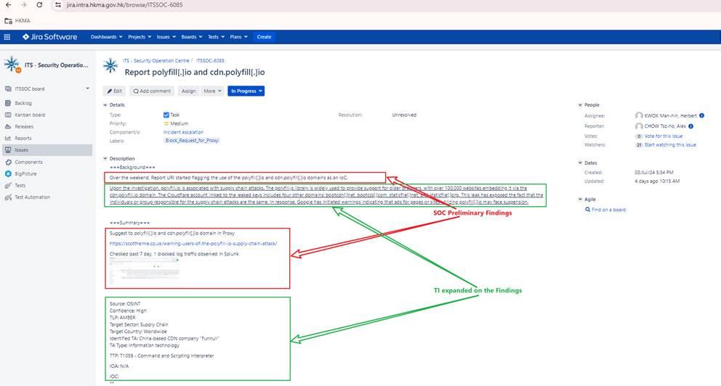
Figure 9: TI Consolidates the findings by SOC

3.2) TI Requests Findings from SOC

If the TI on-site analyst identifies Indicators of Compromise (IoCs) using HKMA security tools (e.g., Splunk, Sentinel One) during a threat hunt, the case should be passed to the SOC on-site analyst for further action. The following steps should be taken:
- TI on-site analyst will create a Jira sub-ticket under the threat hunt parent ticket for the passing case to SOC.
- Ticket component: “incident escalation for TI alerts”
- Ticket title: [incident escalation for TI alerts] %Threat Hunt Ticket Name%
- Ticket content: Include Threat Hunting findings (i.e., the purpose of the IP leveraged by the threat actor) in sub-ticket for SOC’s reference
- SOC on-site analyst will perform analysis on HKMA security solutions, gather and provide observations in the sub-ticket accordingly where necessary, showing below:
- If the IoCs are IP addresses
  - Identify any malicious inbound and outbound traffic
  - Confirm whether such activity has been denied
  - Observe whether there is any callback (for C2 IP address only)
- If the IoCs are file hashes
  - Check the specific recipients of the malware to determine the scope of impacted individual

4) Incident Response (IR)

4.1) IR Initiation and Notifications Phase

4.1.1) Triggering IR
If both the SOC and TI on-site analyst escalate the incident to HKMA's AD(IT)(ITS)3 and necessary to initiate an Incident Response (IR), a corresponding Jira ticket will be created in advance.
If a ticket/incident is related to TI, AD(IT)(ITS)3 will initiate IR to the PwC TI Team. For SOC-related tickets, AD(IT)(ITS)3 will initiate IR to the PwC SOC Team.

4.1.2) Email Notifications by HKMA and PwC
Both HKMA and PwC should send immediate email notifications to their respective senior management to inform them about the decision to trigger the Incident Response (IR) for awareness. The following table outlines the actions taken by each party:

Party | Description
HKMA | AD(IT)(ITS)3 will report to HKMA's Andrew Tam and obtain approval through email, Nexchat, or Jira ticket, as per the established communication channels.
PwC | The TI on-site analyst will report to PwC Threat Intelligence Team Leader Michael Ching via Outlook email and obtain email approval.

The following template is for TI on-site analyst to notify PwC IR Team via email, as applicable.

[Email Template] Notification to IR Team Lead (i.e., Michael Ching)
Suggested Email Template – Notification to IR Team Lead (i.e., Michael Ching)

Subject: [HKMA] Critical %Incident/CVE% Notification - %Incident/CVE Name%

Dear Michael,

As requested by HKMA, there is a critical issue bringing severe impact on %Vulnerability Name%, which %Reason for triggering IR/Impact details% and plus IR is triggered.

Below is the information of the %Incident/CVE Name%. Thank you.

%Incident/CVE% Details:

Incident ID: %Incident ID%
Timestamp: %Timestamp%
Severity: %Severity%
Incident Count: %Incident Count%
Rule Name: %Rule Name%
Rule Description: %Rule Description%
Target host IP: %Target host IP%
Target host Name: %Target host Name%
Details: %Details%
IOAs: %IOAs%
IOCs: %IOCs%
Others: %Others%

Our Threat Intelligence team will provide immediate updates if there are further findings or updated IOCs related to this %Incident/CVE Name%.

Please let me know if you require any further assistance or information.

Best Regards,
%OSSA Name%
TI On-site Security Analyst

4.1.3) Additional Action Items

- PwC TI on-site analyst will collaborate with PwC DFIR Team for the associated artefacts (e.g. ransom note), where applicable

- Analyze associated data sources (e.g. leak site, forums, where applicable) to understand the context and intelligence on the incident and the threat actor

- Any other stakeholder/party need to be informed as needed

4.2) Investigation Phase

4.2.1) Collaboration with PwC DFIR team

PwC TI Team will work with DFIR team along the incident, with objectives to enrich IOCs, TTPs, and knowledge on the threat actor based on the incident and provide support in threat hunting and investigation procedures.

- Identify possible points of initial access (i.e., initial access broker, vulnerable servers, administrative ports, etc.):
- Assist DFIR in the process to collect several forensic artefacts, including the tools used by the threat actor;
- Collaborate with DFIR team to assess Indicators of Attacks (IOAs), including Unusual Login Attempts and Suspicious File Downloads;
- Perform necessary analysis with PwC’s tools, including but not limited to digital footprint intelligence, dark web search, leak sites;
- Set up proactive dark web monitoring of the relevant context keywords.

4.3) Reporting Phase

4.3.1) Contribute Threat Intelligence Perspective in IR Report
The following sections outline how the TI team collaborates with the IR team and contributes to the IR report:
- Executive Summary
- Key Facts (e.g., purpose of the attack, tools used)
- Recommendations / Lessons Learnt
- Sharing a list of artefacts associated e.g. list of Indicators of Compromise (IoC)
- Forensic artifacts in the appendices of the IR report, including details such as:
  - Tool name
  - Description / Purpose
  - Observations
  - MITRE

4.3.2) Ongoing Monitoring of Threat Actors
The PwC Threat Intelligence team will engage in continuous monitoring of Threat Actors, including events, timings, and types of malicious actions taken (e.g., Unauthorized sale of HKMA data.)

Appendix

TI Investigation Tools
Tools that may be leveraged for PwC TI team to perform analysis include (but not limited to):

Type of Tools | Examples | Usage
Forensics | Shodan.io, Censys.io, VirusTotal, Urlscan.io, Pulsedive.com, Whois | Identify current and historical ports observed to be open, potential vulnerability, SSL certificates, etc
Community-based | Abuseipdb.com, VirusTotal | Ascertain if IP address or domain was reported as malicious
Dark Web Search Engine | Duckduckgo, Torch, Ahmia | Helps find, understand, and deal with online threats that come from hidden parts of the internet

Other Sources
The PwC Threat Intelligence Team may utilize various sources before and during the incident, including but not limited to the following:

- 百度: www.baidu.com
- 微步在线: x.threatbook.cn
- 腾讯哈勃: habo.qq.com
- Virscan: virusscan.jotti.org
- Freebuf: www.freebuf.com
- Jotti: virusscan.jotti.org
- Scandir: www.scandir.com
- Alexa排名: www.alexa.com
- 备案查询: beian.cndns.com
- 深信服安全中心: sec.sangfor.com.cn
- 深信服威胁分析平台: wiki.sec.sangfor.com.cn
- 深信服EDR安全软件中心: edr.sangfor.com.cn

Incident Escalation for HKMA Evaluation

- Assessing the relevance of the incident against HKMA (e.g., Potential match with HKMA’s basic Inventory List on technology)

- Assessing the relevance of the incident to Hong Kong

- Assessing the relevance of the incident with respect to whether the industry is typically recognized globally and/or locally as a critical infrastructure operator (e.g., Singapore Cyber Security Act may have a list of Essential Services)

- Assessing the relevance of the incident to specific industries that are relevant to HKMA (e.g., Global Central Banks, Fintech, Financial Services, and Property Development, etc.)

- If PwC cannot find any publicly available information regarding the incident or if the incident has not been publicly disclosed, PwC will provide the findings of their analysis (if any) to HKMA via email including relevant case studies of incident experiences, where applicable

- HKMA provides the information on IOC to PwC TI / SOC on-site analyst for further investigation

- Upon request by HKMA, PwC will provide a summary regarding publicly reported incidents based on their understanding from OSINT, and the expected turnaround is as follows:
Time Range | Description | Expected Turnaround
During office hours | Monday to Friday, 9 AM to 6 PM | 1) PwC on-site analyst should analyze the request with the TI Team, provide a preliminary response within a business day upon HKMA’s request.  2) Provide timely updates on HKMA’s request, if necessary.
During non-office hours | The time outside of office hours

NOTE: At times where HKMA makes urgent requests for specific TI, PwC will initially agree the associated turnaround time with HKMA on a case-by-case basis.
In such a scenario, the following are the steps required:
1) PwC TI / SOC on-site analyst should immediately inform the Cyber Threat Operations Leads (Jason Lee, Michael Ching) about the request.
2) Analyze the request with the TI Team, provide a preliminary response with the agreed SLA upon HKMA’s request.

Finding the Names of HKMA System Owners

To identify relevant HKMA staff members to notify and locate the names of system owners within HKMA, TI on-site analysts should:
a) Access the HKMA authorized computer
b) Open the USO Client application.
c) Launch Lotus Notes 9 on HKMA computer.
d) Within Lotus Notes, navigate to the "HKMA Phone List" section.
e) Perform keyword search using relevant keywords such as "AD(IT)" for the Information Technology Associate Director.
6) If uncertain about the specific roles or unable to find the relevant system owner, contact AD(IT)(ITS)3 for further assistance.

Content of SOP |  |  | PwC follow up action on Version Control |  |  |  |  |  |  |  |  | SOP Trial Run | Lesson Learnt (Since Last Modification)
 | 2 June | 2 Aug |  | 25 Sep | 5 Nov | 27 Nov | 20 Dec | 21 Jan | 24 Feb | 26 Mar | 31 Jul
Cyber Threat Operations (CTO) | 1st Draft | 2nd Draft |  | 3rd Draft | First Endorsement | 1st Modification of First Endorsement | 2nd Modification of First Endorsement | 3rd Modification of First Endorsement | Latest Endorsement | 1st Modification of Latest Endorsement | 2nd Modification of Latest Endorsement | Since 2 June 2024 | 1) CVE Notification Email Delivery  - As requested by AD(IT)(ITS)3, Include all IT, FMI, HKDPB Associate Directors (ADs) in CVE notification emails could enhance overall situational awareness.  2) Follow-up actions required by users if affected by CVE  - Enhance and Include a Summary Table in CVE notification email for System Owner to fill in / provide the following information:  - Internet Facing (Yes / No)  - Affected System / Server IP(s)  - Target Solution Apply / Patch Date  - Such measures could make it easier to track which systems are affected and who is responsible for remediation, enhance robust visibility.
Threat Hunting | Not yet released | 1st Draft |  | No Modification | First Endorsement | No Modification | No Modification | 1st Modification of First Endorsement | Latest Endorsement | 1st Modification of Latest Endorsement | No Modification | Since 2 Aug 2024 | Nil
Security Operations Centre (SOC) | 1st Draft | 2nd Draft |  | No Modification | First Endorsement | No Modification | 1st Modification of First Endorsement | 2nd Modification of First Endorsement | No Modification | No Modification | No Modification | Since 2 June 2024 | Nil
Incident Response (IR) | Not yet released | 1st Draft |  | No Modification | First Endorsement | No Modification | No Modification | No Modification | No Modification | No Modification | No Modification | Since 2 Aug 2024¹ | Nil
Legend
Reviewed by HKMA
Not yet reviewed by HKMA
Not yet released
No Modification compared with previous version
Footnote
¹ Not yet Triggered
Estimated TI SOP Progress (snapshot since 28 July 2025)

Define Threat Severity (Purposed by PwC; Not Adopted by HKMA)
The following criteria should be considered to determine the threat severity:
- Internet Facing System
- CvSS v3 Impact Score
- *PwC Client Product Coverage (Known use by various SOC client)
- Exploited in the Wild
*It is a proprietary source by PwC
NOTE: At times where HKMA makes manual override of Final Severity Level for specific TI, PwC will initially agree on the associated Final Severity Level with HKMA on a case-by-case basis.

Threat Severity Matrix (Purposed by PwC; Not Adopted by HKMA)
System Type | CVSS V3 Impact Score | PwC Client Product Coverage | Exploited in the Wild | Final Severity Level
Internet Facing System
 | 9.0-10.0 | Yes | Yes | Critical
 | 7.0-8.9 | Yes | Yes | High
 | 4.0-6.9 | Yes | Yes | Medium
 | 0.1-3.9 | Yes | Yes | Low
 | 9.0-10.0 | Yes | No | High
 | 7.0-8.9 | Yes | No | Medium
 | 4.0-6.9 | Yes | No | Medium
 | 0.1-3.9 | Yes | No | Low
 | 9.0-10.0 | No | Yes | High
 | 7.0-8.9 | No | Yes | Medium
 | 4.0-6.9 | No | Yes | Medium
 | 0.1-3.9 | No | Yes | Low
 | 9.0-10.0 | No | No | High
 | 7.0-8.9 | No | No | Medium
 | 4.0-6.9 | No | No | Low
 | 0.1-3.9 | No | No | Low
Non-Internet Facing System
 | 9.0-10.0 | Yes | Yes | Medium
 | 7.0-8.9 | Yes | Yes | Medium
 | 4.0-6.9 | Yes | Yes | Medium
 | 0.1-3.9 | Yes | Yes | Low
 | 9.0-10.0 | Yes | No | Medium
 | 7.0-8.9 | Yes | No | Medium
 | 4.0-6.9 | Yes | No | Low
 | 0.1-3.9 | Yes | No | Low
 | 9.0-10.0 | No | Yes | Medium
 | 7.0-8.9 | No | Yes | Medium
 | 4.0-6.9 | No | Yes | Low
 | 0.1-3.9 | No | Yes | Low
 | 9.0-10.0 | No | No | Medium
 | 7.0-8.9 | No | No | Low
 | 4.0-6.9 | No | No | Low
 | 0.1-3.9 | No | No | Low
Figure 10: Threat Severity Matrix

The Government of the Hong Kong Special Administrative Region of the People’s Republic of China. (2024, April). Practice Guide for IT Security Threat Management. OGCIO. https://www.govcert.gov.hk/doc/PG_for_IT_Security_Threat_Management-v1.0_EN.pdf
The Government of the Hong Kong Special Administrative Region of the People’s Republic of China. (2024, April). Practice Guide for IT Security Threat Management. OGCIO. https://www.govcert.gov.hk/doc/PG_for_IT_Security_Threat_Management-v1.0_EN.pdf
https://confluence.intra.hkma.gov.hk/spaces/ITDPAR/pages/145562303/Technology+Stack+Reference
https://172.28.80.24
https://masp.hkma.gov.hk/sites/SOCFilingDB/Lists/SOC%20Filing%20Database/DispForm.aspx?ID=100&Source=https%3A%2F%2Fmasp%2Ehkma%2Egov%2Ehk%2Fsites%2FSOCFilingDB%2FLists%2FSOC%2520Filing%2520Database%2FBy%2520Category%2Easpx%3Fweb%3D1&ContentTypeId=
Cybersecurity act. Default. (2024, June). https://www.csa.gov.sg/faq/cybersecurity-act
Hong Kong Monetary Authority (2024, June). Regulatory Resources. https://www.hkma.gov.hk/eng/regulatory-resources/regulatory-guides/by-subject-current/
https://masp.hkma.gov.hk/sites/SOCFilingDB/Lists/SOC%20Filing20Database/By%20Category.aspx?web=1
Cybersecurity act. Default. (2024, June). https://www.csa.gov.sg/faq/cybersecurity-act
Hong Kong Monetary Authority (2024, June). Regulatory Resources. https://www.hkma.gov.hk/eng/regulatory-resources/regulatory-guides/by-subject-current/

